Peripheral # 1 : Mac Address: 51:62:5E
Central Mac : 51:42:DA
Periodic Adv PDU Time (From Central): 331445-308945= 22,500ms OR 22.5 Secs
Explanation: Peripheral # 1 (51:62:5E) getting the periodic adv. ACK from the central (51:42:DA) ,Every 22.5 secs set at Central End. This Combined ACK have both the Peripheral’s(1&2) MAC addresses.
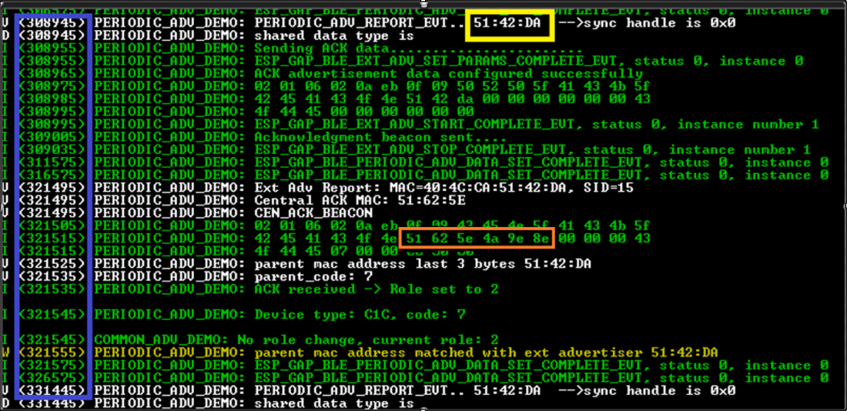

Peripheral # 2 : Mac Address: 4A:9E:8E
Central Mac : 51:42:DA
Periodic Adv PDU Time (From Central): 1230005-1207505= 22,500ms OR 22.5 Secs
Explanation: Peripheral # 2 (4A:9E:8E) getting the periodic adv. ACK from the central (51:42:DA) ,Every 22.5 secs set at Central End. This Combined ACK have both the Peripheral’s(1&2) MAC addresses.
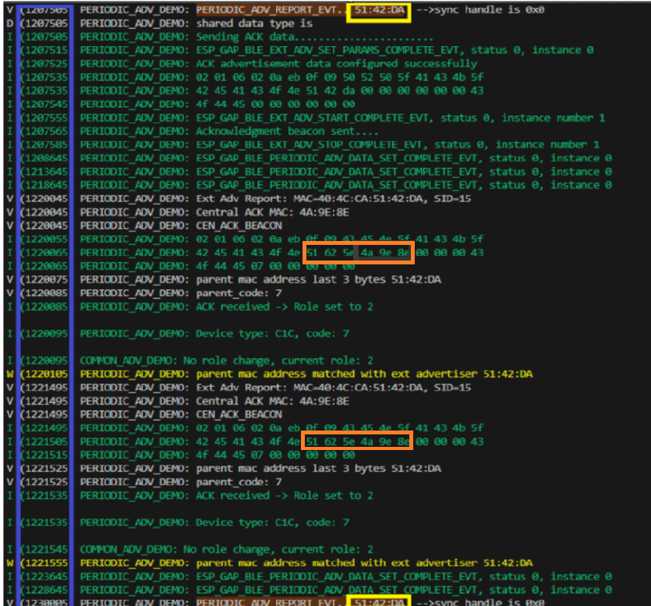

Central: (Periodic ADV PDU From Peripheral # 1)
Peripheral # 1 (Mac Address: 51:62:5E)
Handle:0x0
Periodic Adv PDU Time (From Peripheral # 1): 1476165-1461165= 15,000ms OR 15 Secs
Explanation: Peripheral # 1 (51:62:5E) sending the periodic adv to the central (51:42: DA), Every 15 secs set at Peripheral End.
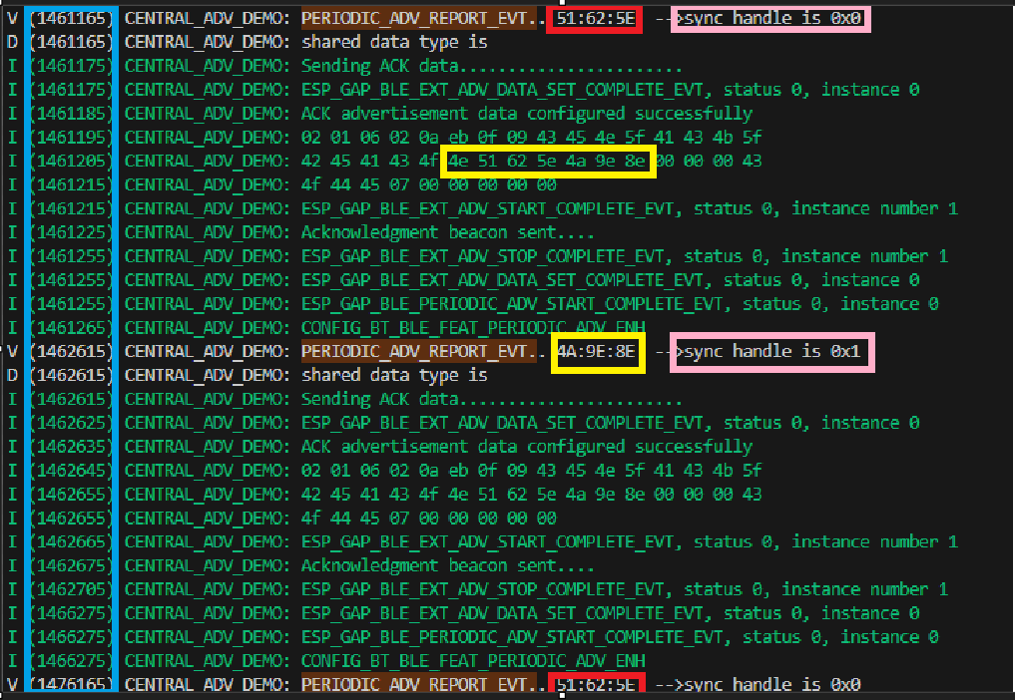

Central: (Periodic ADV PDU with Peripheral # 2)
Peripheral # 1 (Mac Address: 4A:9E:8E)
Handle:0x1
Periodic Adv PDU Time (From Peripheral # 2): 7597655-7582655= 15,000ms OR 15 Secs
Explanation: Peripheral # 1 (4A:9E:8E) sending the periodic adv to the central (51:42: DA), Every 15 secs set at Peripheral End.

